Name______________

My Emotion Regulation Plan

|  |  |  |  |
| --- | --- | --- | --- |
| **Emotion** | **What does it feel like?** | **What does it look like?** | **I can try** |
|  |  |  | **At School**  **At Home** |
|  |  |  | **At School**  **At Home** |
|  |  |  | **At School**  **At Home** |
|  |  |  | **At School**  **At Home** |
|  |  |  | **At School**  **At Home** |



What emotion am I feeling?

**Draw a picture**

How strong is this feeling? Sometimes you might feel an emotion just a tiny bit and other times you might feel it a lot. Think about how you are feeling right now and rate this emotion on this scale.

1

A little

5

A lot

2 3 4

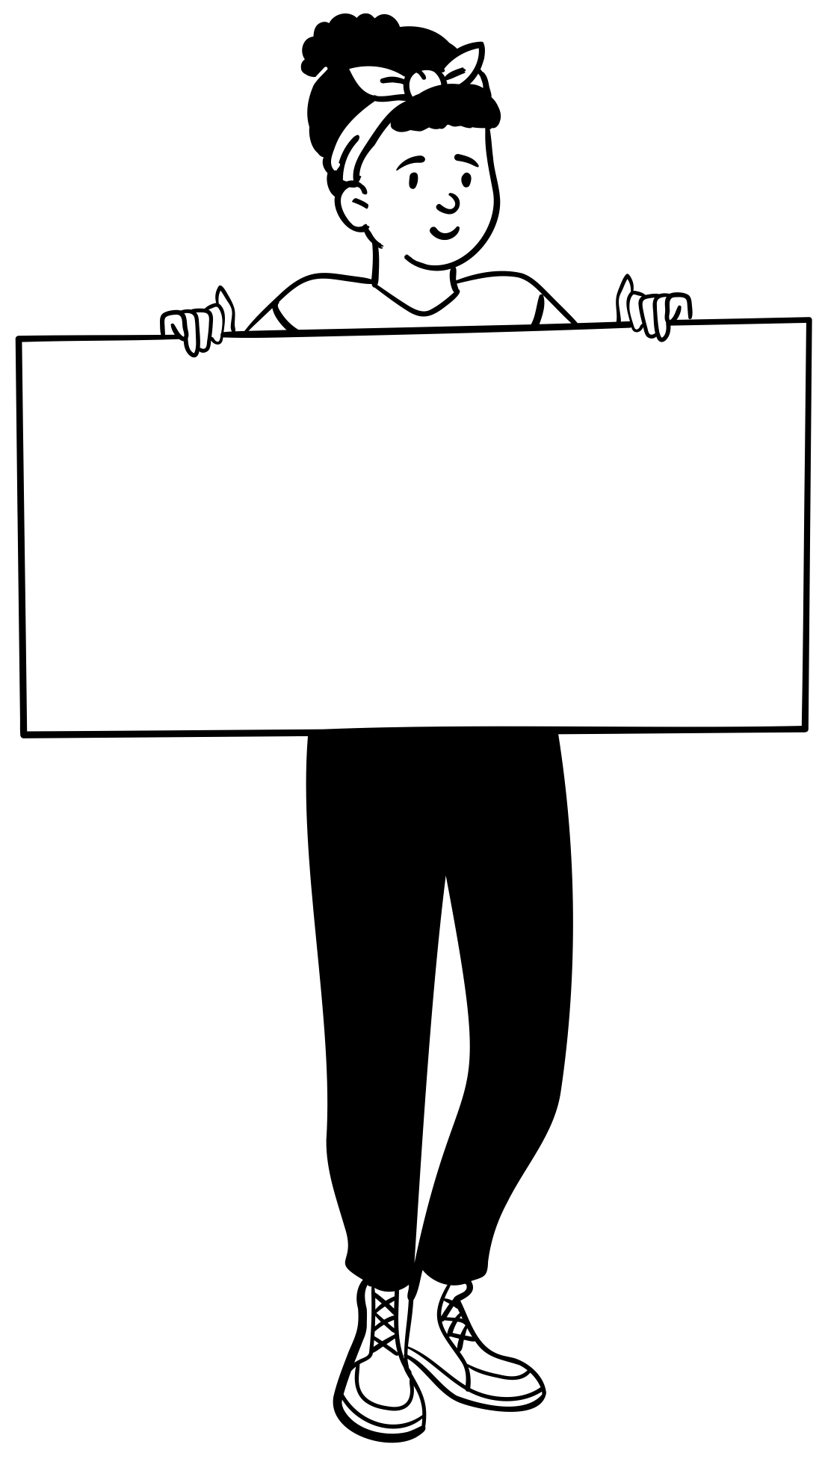

Did that help? If not, try another

**Which coping skill are you going to try?** **Which skill are you going to try next?**

Now it is time to try one of your coping skills!

______________________________ ­­­­___________________________



If these are not working, ask for support!

**Who can support me? (teacher, staff member, friend, coach, family member, mentor)**

__________________________________________________________________

