Daily Report Card

Child’s Name: _____________________________ Date: ____________
Target Behavior | Behavior Tracked  (Frequency) | Goal Met?
Ava raises her hand to speak with 3 or fewer instances of interruptions.   |  |     or
Ava stays seated with 2 or fewer violations.   |  | or
Ava uses materials appropriately with 2 or fewer violations.  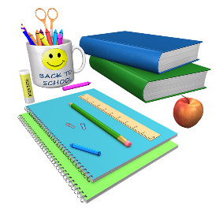 |  | or

Reward Given:

Teacher’s Signature: ____________________________________________________

Comments:

Parent’s Signature: ____________________________________________________


